**Super Store**

**Furniture**

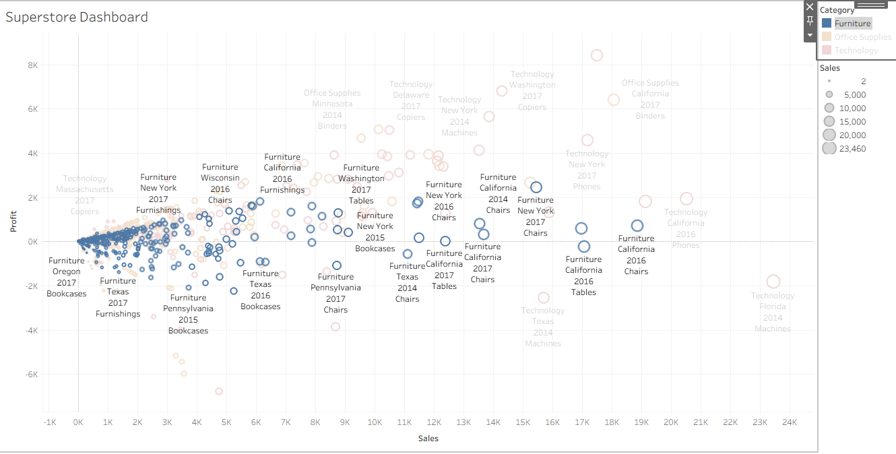

**Office Supplies**

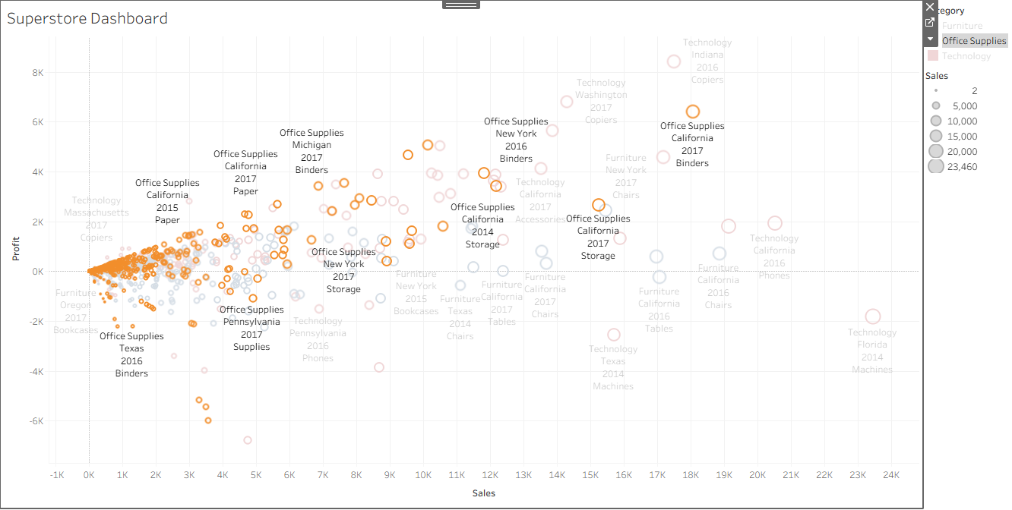

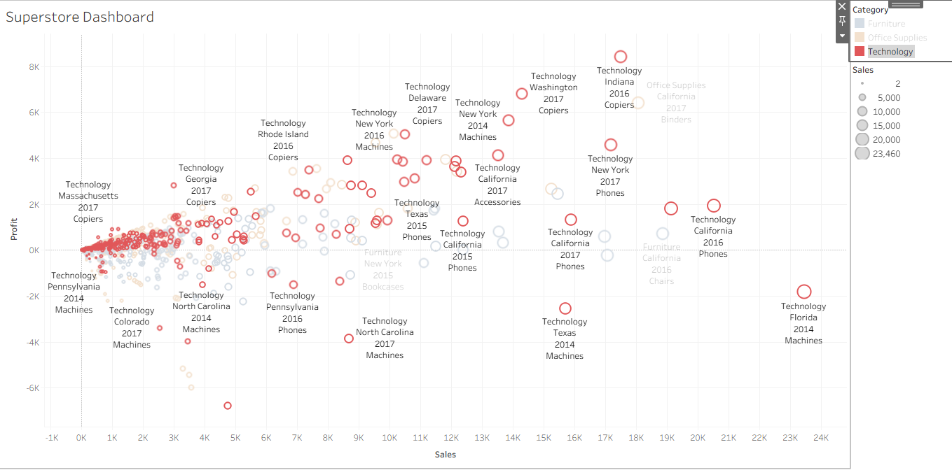**Technology**

**Over all**

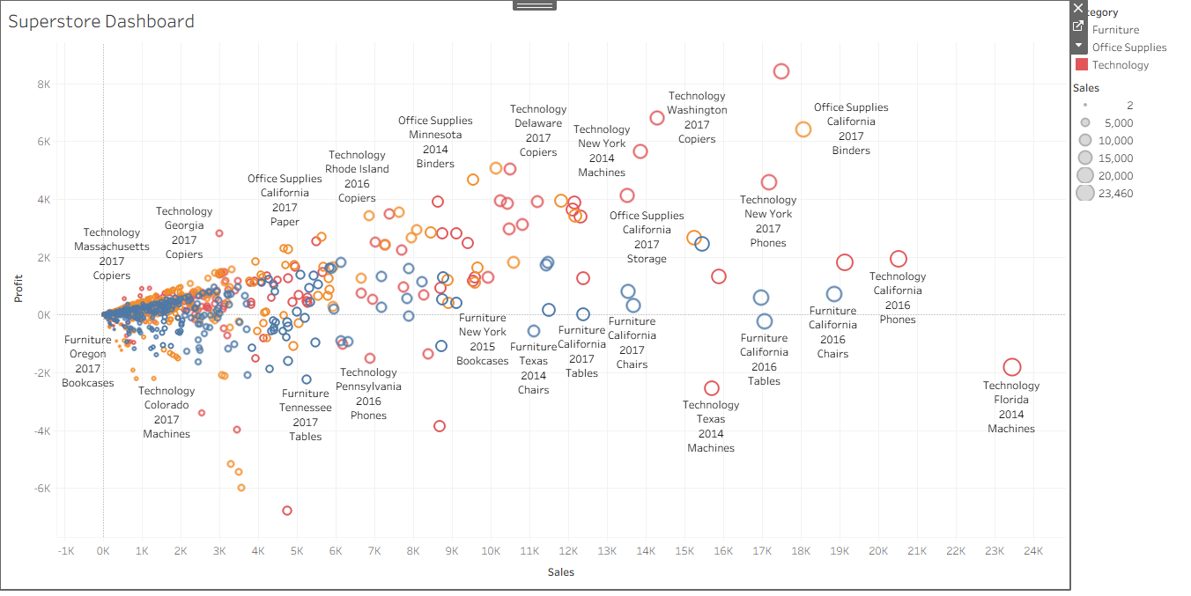

**1. Sales by Region**

**Title:** *“Sales Distribution across Regions”*  
**Insight:**

The **West and East regions** contribute the highest sales, but the **South** has noticeably lower performance. This could be a focus area for marketing or promotional efforts.

**2. Profit by Category**

**Title:** *“Profitability by Product Category”*  
**Insight:**

Although **Technology** yields the **highest profit margins**, the **Office Supplies** category, while selling well, shows **relatively lower profits**, indicating possible pricing or cost issues.

**3. Monthly Sales Trend**

**Title:** *“Monthly Sales Trend Over Time”*  
**Insight:**

Sales follow a **seasonal pattern**, with noticeable **peaks in Q4 (October–December)**, suggesting that promotional campaigns or holiday seasons boost performance significantly.

**4. Sales by Sub-Category (Tree Map)**

**Title:** *“Contribution of Sub-Categories to Total Sales”*  
**Insight:**

**Phones and Chairs** are the **top-selling sub-categories**, while **Copiers and Tables** also contribute significantly. This identifies which products are driving overall revenue.

**5. Profit vs Sales (Scatter Plot)**

**Title:** *“Relationship Between Sales and Profit”*  
**Insight:**

Some sub-categories like **Tables** show **high sales but negative profit**, suggesting potential issues with pricing, discounts, or supplier cost. Profit doesn’t always follow sales.

**6. State-Wise Sales Map**

**Title:** *“Sales Performance by State”*  
**Insight:**

**California** and **New York** lead in sales, while many **Midwestern states** lag behind. These geographical insights can inform targeted regional marketing strategies.

**7. Segment-Wise Profit Contribution**

**Title:** *“Profitability by Customer Segment”*  
**Insight:**

The **Corporate** segment has the highest profit per sale, while the **Consumer** segment contributes the most to total profit volume, indicating a balance of bulk vs. scale.

**📌 Dashboard Summary / Key Insights**

* West and East regions dominate in sales, but South is underperforming.
* High revenue in Office Supplies doesn’t translate into profit — pricing needs review.
* Strong Q4 performance suggests seasonality in sales.
* Sub-category-level analysis reveals loss-making items despite high sales (e.g., Tables).
* Geographic and segment-level insights can drive more focused business decisions.

Bottom of Form